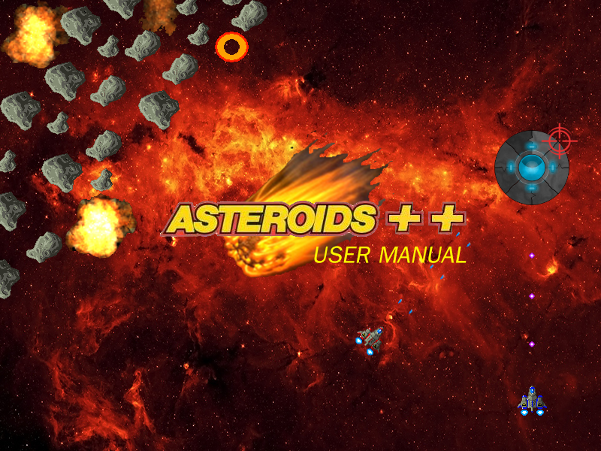

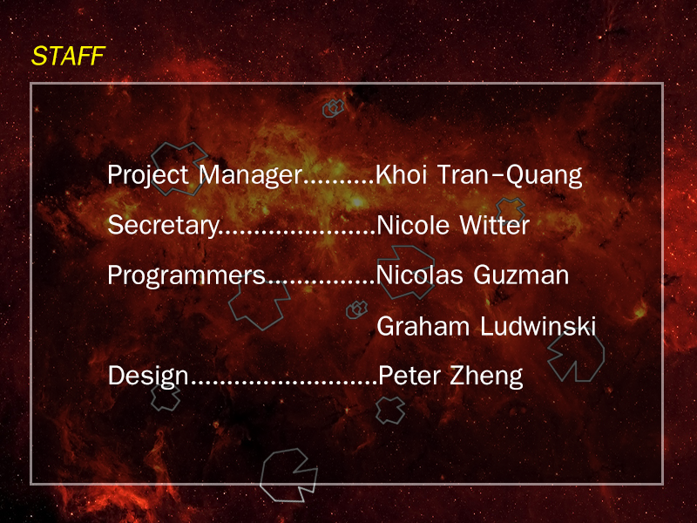

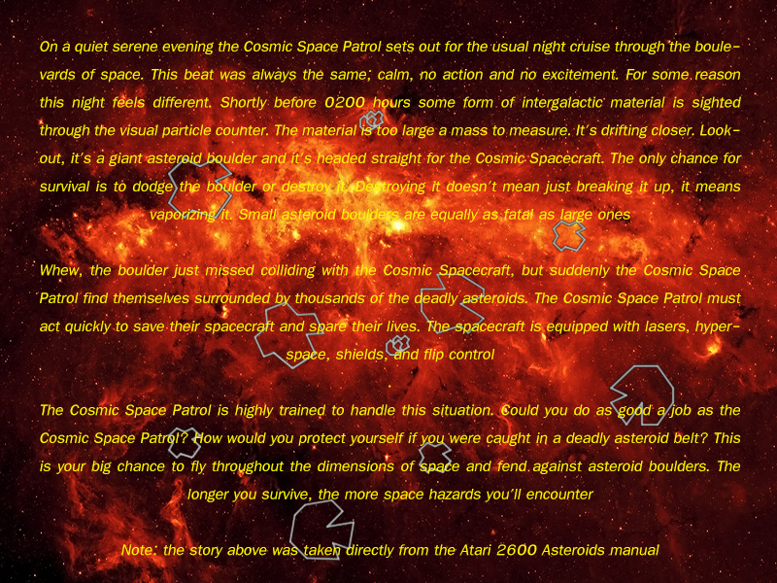

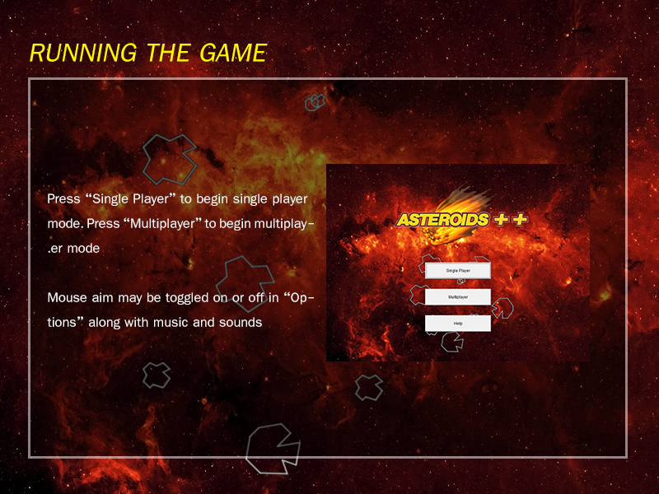

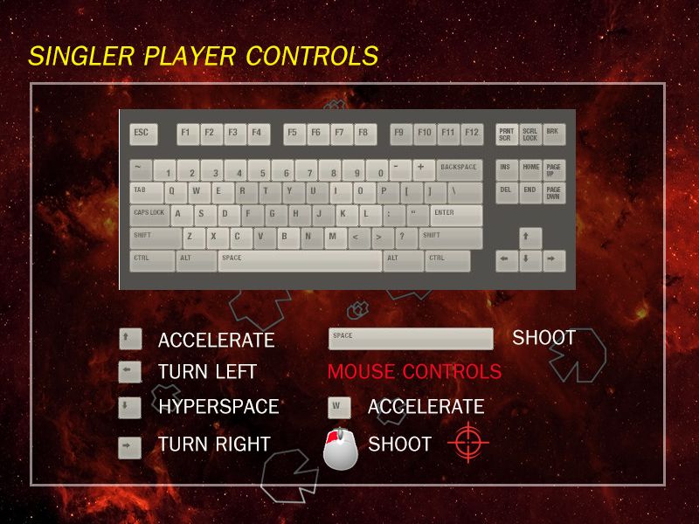

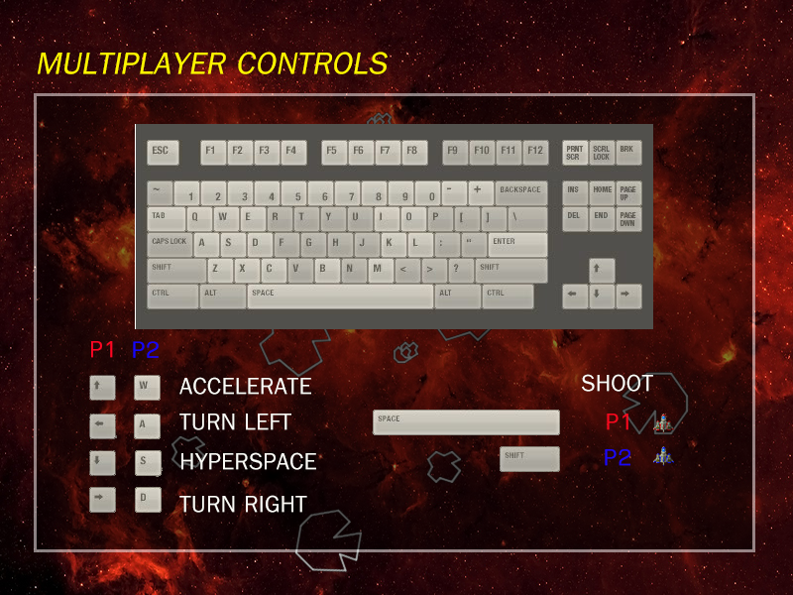

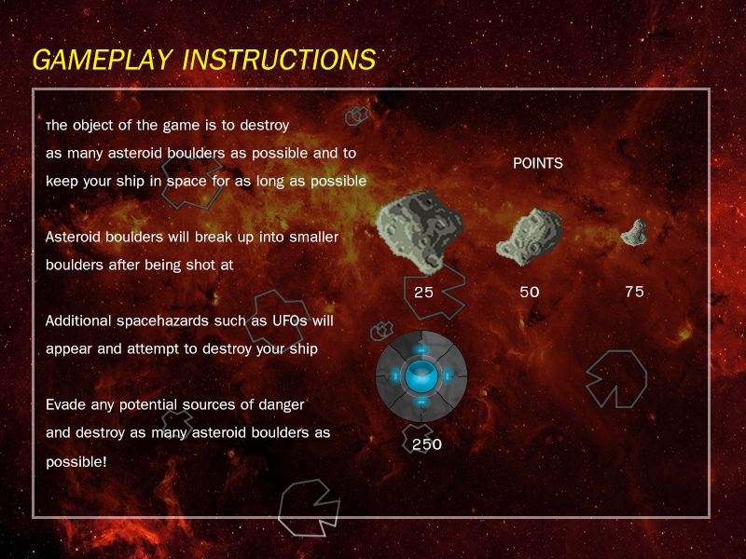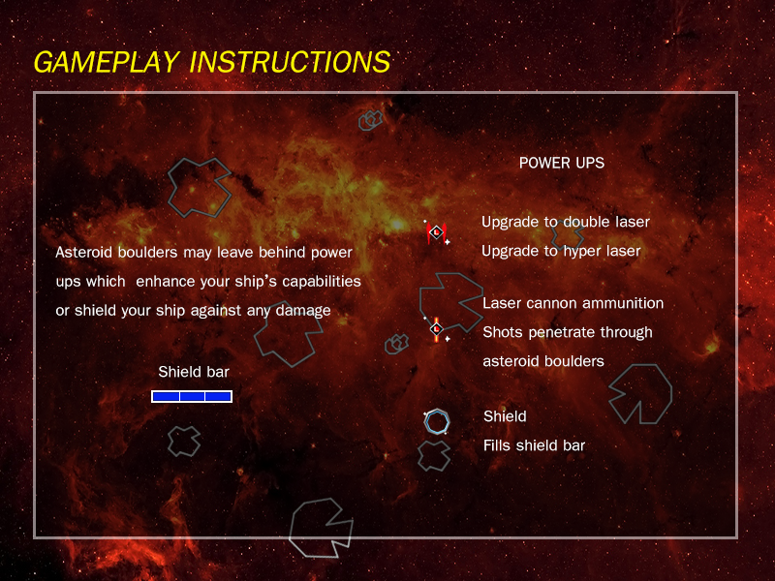

**KNOWN BUGS**

* **Ship collides with unknown entities (possibly due to architecture of the code)**
* **If multiple power ups appear on the field, they are always the same**
* **Hyperspace does not work**
* **When laser cannon ammo reaches zero, the player always reverts back to the worst shot, and not the latest laser power up that the player has collected**
* **Player does not have a period to recuperate after death**